Old Swedes ChurchThe Old Swedes Historic Site www.oldswedes.org
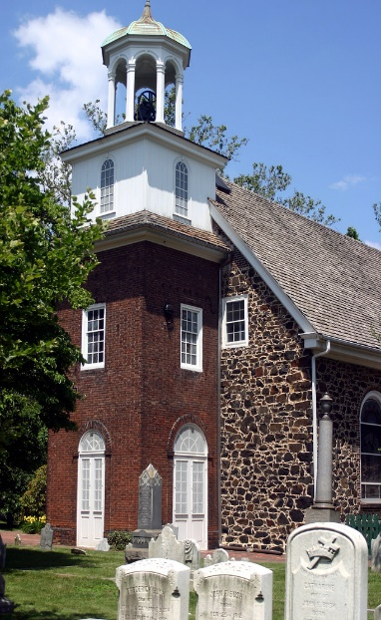
Old Swedes Church build on the grounds of what is now Old Swedes Historic Site in Wilmington, DE. The church was constructed 1698-1699 and is one of the very few surviving remnants of the New Sweden Colony in the Delaware Valley. It is one of the oldest structures in Delaware. The site was used as a burial ground for the Fort, but also holds signs of earlier use by the Lenape Native Americans.
This Photo by Unknown Author is licensed under CC BY-SA

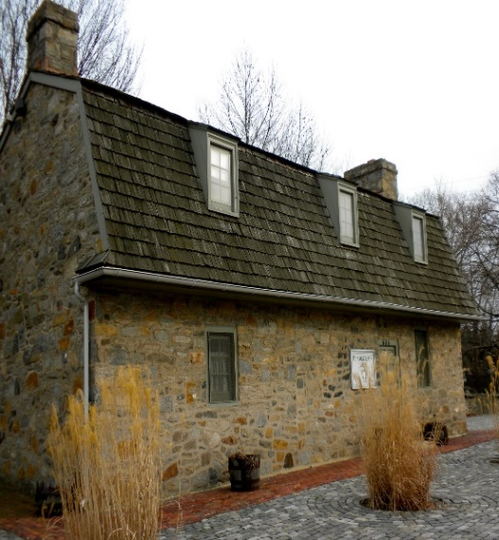
Hendrickson House www.oldswedes.org
The Hendrickson House is one of the oldest houses in the state of Delaware and one of the oldest surviving Swedish-American homes in the United States.
The house was originally built in 1690 in Chester, Pennsylvania as the home of Swedish farmer, Andrew Hendrickson and his wife, Brigitta Morton, who were both born in the New Sweden colony.
The House was preserved and relocated to the grounds of the Old Swedes Historic Site in 1960 to serve as a museum, office, and research space.

